Título 1STD Version 2.9p C:\Gloria\NORMASG\templates\2021\acabadas\CWA_XXXX_(E)_tr.docx 1 2 16 prCWA XXXX:2021 (E) 40Título 2 0 0CEN 062021prCWA XXXX:2021UNEGuidelines for the assessment of resilience of transport infrastructure to potentially disruptive events CWA CEN Enquiry 00 E Falso 00CWA XXXXCEN/TC
Date: 2025-01
prCWA XXXX:2021
Workshop
Secretariat: UNE
Guidelines to establish the carbon bill of the refurbishment of buildings

Contents
Page
European foreword 3
Introduction 4
1 Scope 7
2 Normative references 7
3 Terms and definitions 7
4 Framework for the WLC assessment 8
4.1 General 8
4.2 Steps in the calculation 8
4.2.1 Goal, scope and scenario definition 8
4.2.2 Life cycle stage modelling 9
4.2.3 Mass and energy balance 9
4.2.4 LCI data for indirect GHG emissions 9
4.2.5 Interpretation 9
4.3 Calculation of the WLC-GWP 9
5 Methodology for the WLC calculation 11
5.1 General 11
5.2 Description of the stages for the WLC-GWP calculation 11
6 Calculation of the carbon bill considering the life cycle 12
6.1 General 12
6.2 Calculation 12
6.3 Price of carbon credits 12
6.4 Additional considerations 13
7 Process for the definition of the refurbishment and the calculation of the carbon bill 13
7.1 Preassessment 13
7.2 Recommendations for the refurbishment 13
7.3 Assessment of the as-built 13
8 Normalization, update and reporting of the carbon bill of the refurbishment 15
Bibliography 17

European foreword
XXXXXX was developed in accordance with CEN-CENELEC Guide 29 “CEN/CENELEC Workshop Agreements – The way to rapid agreement” and with the relevant provisions of CEN/CENELEC Internal Regulations – Part 2. It was agreed on DATE in a Workshop by representatives of interested parties, the constitution of which was supported by CEN and CENELEC following the public call for participation made on DATE. However, this CEN and CENELEC Workshop Agreement does not necessarily include all relevant stakeholders.
The final text of CWA XXXXXX was submitted to CEN and CENELEC for publication on DATE.
The following organizations and individuals developed and approved this document:
— LIST OF ORGANIZATIONS
Attention is drawn to the possibility that some elements of this document may be subject to patent rights. The CEN-CENELEC policy on patent rights is described in CEN-CENELEC Guide 8 “Guidelines for Implementation of the Common IPR Policy on Patent”. CEN and CENELEC shall not be held responsible for identifying any or all such patent rights.
Although the Workshop parties have made every effort to ensure the reliability and accuracy of technical and non-technical descriptions of this document, the Workshop is not able to guarantee, explicitly or implicitly, its correctness. Anyone who applies this document should be aware that neither the Workshop participants, nor CEN and CENELEC, can be held liable for damages or losses of any kind whatsoever which may arise from its application. The use of this CEN and CENELEC Workshop Agreement does not relieve users of their responsibility for their own actions, and they apply this document at their own risk.
This document is a result of the studies and activities performed under FORESEE project, funded under European Union’s Horizon 2020 Research and Innovation Framework under grant agreement No 769373.

Introduction
Buildings play a significant role in global greenhouse gas (GHG) emissions, accounting for approximately 40.3% of total energy consumption and 34.4% of CO₂ emissions in the European Union (EU) alone. Therefore, the built environment is a critical sector for achieving the carbon neutrality goals established by the EU for 2050. In In this context, the recently updated Directive on the Energy Performance of Buildings (EPBD) [1] is a cornerstone of EU policies, as it defines strategies and requirements to increase efficiency of the building stock.
The revised EPBD aims to ensure that the building sector contributes to the overarching goal of reducing net greenhouse gas emissions by at least 55% by 2030. One of the overarching objectives is the decarbonization of EU's building stock, reducing the energy demand and promoting the use of renewable energy sources. The implementation of energy-efficient retrofitting and construction techniques has the potential to reduce energy expenditure for households and businesses, address the issue of energy poverty, and stimulate the creation of green jobs in sectors such as construction, manufacturing, and technology. Furthermore, the creation of healthier indoor environments has the capacity to enhance public health and productivity, thereby aligning with broader societal objectives established in EU policies.
The revised EPBD introduces measures to address embodied GHG emissions, associated with production, transportation, construction, and disposal of building materials. The strategies to reduce these emissions include enhancing building insulation (including windows), using low-carbon materials, enhancing recycling practices, fostering modular construction techniques or the use of solar panels for electricity generation and water heating. Nearly Zero Energy Buildings (NZEBs) will have a minimized energy demand for heating, cooling, lighting and other operations; and low (nearly zero) primary energy consumption.
The Declaration of Performance and Conformity defined in the new Construction Products Regulation (new CPR) [2] will include the GWP of construction products covered by a harmonized standard. This information can be integrated in the calculation of the GWP of the building, as defined in EN 15978.
Digitalization should also contribute to reductions of emissions, applying automated systems to optimize heating, cooling and lighting, and installing smart meters and sensors to track and optimize energy use. Smart Readiness Indicators (SRI) should be used to assess the building’s capacity to use smart technologies and integrate renewable energy sources efficiently. This will promote innovation and digitalization in the sector. In addition, the new CPR will provide GWP data in a digital format with the Digital Product Passport (DPP). This digital EPD data must be machine-interpretable in order to be efficiently integrated into a building-level digital model for LCA calculations [3]. EN ISO 22057 [4] defines a structured data template to integrate LCA-data in BIM, which can include both EPD and generic LCA data [5].
It is essential to base informed material and design choices on a comprehensive evaluation of the building's full lifecycle impacts. In this regard, CEN/TC 350 have developed standards for life cycle assessment of construction assets, including buildings, based on data from products and the processes required for the installation and construction, operation (including maintenance), and the end-of-life stage. In particular, EN 15978:2011 for buildings and EN 15804:2012+A2:2019 for environmental product declarations define the framework for any environmental assessment of the building stock with a lifecycle perspective.
The implementation of the EPBD’s should support the EU’s climate and energy policies, including the Renewable Energy Directive, the Energy Efficiency Directive, and the Emissions Trading System (ETS). The ETS is a market-based mechanism designed to reduce GHG emissions by assigning a price to them. The system, established in 2005, is the world's first and largest cap-and-trade system, playing a central role in the EU’s climate policy to achieve its carbon neutrality goals. The EU- ETS covers about 40% of the EU’s GHG emissions, including power and heat generation, energy-intensive industries, aviation and maritime transport. The ETS operates on the principles of cap-and-trade, involving three key components:
- Cap on Emissions: A total limit (cap) is established on the amount of GHG emissions that covered sectors can emit annually. This cap is reduced over time to drive reductions in emissions and align with long-term climate targets.
- Allocation of Emission Allowances: Organizations in the covered sectors receive or purchase emission allowances (EU Allowances). EUAs represents the right to emit one metric ton of CO₂ equivalent (tCO₂e).
- Trading of Allowances: Organizations that emit less than their allocated allowances can sell the surplus, while those exceeding their allowances must buy additional permits or face penalties.
This document is based on CHRONICLE’s deliverable 2.2, “dynamic Level(s) approach for building and LC performance assessment” [6] and deliverable 4.3 “tool suite for WLC assessment and climate neutral building renovation planning” [7]. It also considers other documents from the project, e.g. [8]. CHRONICLE (Grant Agreement 101069722) is an EU-funded research and innovation project which digitalizes building information and promotes the use of dynamic logbooks for future value-driven services. It aims to improve building performance to increase energy efficiency, comfort and well-being. The approach define in the project has been tested in pilots located in five countries: Denmark, Greece, Ireland, Spain and Switzerland. Task 6.6 deals with standardization and has been collaborating in the standardization of operational energy performance assessments in CEN/TC 371/WG 5. In addition, it has been working in the definition of a digital twin to be used for building assessment purposes.
This document proposes the calculation of the carbon bill of buildings based on the GWP defined in EN 15978 and the price for emissions allowances in Europe. Based on calculation, the carbon bill of the refurbishment is defined as the difference between the carbon bill of the existing building and the carbon bill after the renovation, both with a lifecycle perspective. This document can be used to support the “polluter pays” principle from a “positive” perspective, encouraging renovations that reduce the carbon footprint over the life cycle of a building.
The methodology should not be considered a sustainability or environmental assessment, as it only covers GHG emissions. Other impact categories and indicators related to water quality or circularity must be included in any comprehensive assessment. Environmental assessments of buildings will be based on the latest version of EN 15978.

Scope
This document defines the carbon bill (CB) of a building based on the global warming potential according to EN 15978. The CB of a refurbishment is calculated comparing the situation of the refurbished building and the situation without the refurbishment.

Normative references
The following documents are referred to in the text in such a way that some or all of their content constitutes requirements of this document. For dated references, only the edition cited applies. For undated references, the latest edition of the referenced document (including any amendments) applies.
ISO 16745-1:2017 Sustainability in buildings and civil engineering works — Carbon metric of an existing building during use stage — Part 1: Calculation, reporting and communication
EN 15804:2012+A2:2019 Sustainability of construction works - Environmental product declarations - Core rules for the product category of construction products
EN 15978 Sustainability of construction works - Assessment of environmental performance of buildings - Calculation method

Terms and definitions
For the purposes of this document, the following terms and definitions apply.
ISO and IEC maintain terminological databases for use in standardization at the following addresses:
— IEC Electropedia: available at http://www.electropedia.org/
— ISO Online browsing platform: available at http://www.iso.org/obp
2.1 building
construction works that have the provision of shelter for their occupants or contents as one of their main purposes and are usually enclosed and designed to stand permanently in one place
[SOURCE: EN 15653:2021]
2.2 carbon bill of a building
economic value, including any externalities, of the total greenhouse gas emissions associated with the building (2.1) throughout its lifecycle
2.3 carbon bill of a refurbishment
economic value, including any externalities, of the greenhouse gas emissions associated with the refurbishment (2.6) of a building (2.1), including the emission after the refurbishment and subtracting the emission of the non-refurbished building
2.4 construction product
item manufactured or processed for incorporation in a building (2.1)
[SOURCE: ISO 6707-1:2020, modified. “Construction works” has been changed to “a building”]
2.5 operational energy use
energy use during use and operation of the building (2.1)
[SOURCE: EN 15653:2021, modified. “The construction works” has been changed to “building”]
2.6 refurbishment
planned large scale (substantial) modification and improvements to existing buildings (2.1)
Note 1 to entry: Refurbishment can be undertaken to facilitate continuation of the current function, including technical modernization and a change of space plan, or a change of function to new use.
[SOURCE: EN 15653:2021, modified. “Construction works” has been changed to “buildings”]

Framework for the WLC assessment

General
The methodology is designed to consider the interests of various stakeholders involved in a construction project at every stage of its lifecycle. This includes project design teams, clients and investors (both public and private), public policymakers, and national, regional, and local procurement authorities. The framework is designed to be flexible enough to accommodate users with different levels of experience and technical expertise.
The Level(s) framework is based on six macro-objectives and sixteen core indicators. From WLC assessment perspective, the macro-objective 1 "Greenhouse gas and air pollutant emissions along a building’s life cycle" and its indicator 1.2 "Life cycle Global Warming Potential" play a central role. This indicator measures the GHG emissions associated with the building at different stages of its lifecycle and the building's contribution to the emissions responsible for global warming and climate change. The indicator combines the carbon emissions specific to building materials with direct and indirect carbon emissions from the building's operational phase. By employing a cradle-to-grave approach, we can balance the embodied carbon of existing buildings against the carbon emitted during their use. This allows the designer to identify design solutions that support the future reuse of building materials and components.
The indicator should be calculated as Global Warming Potential (GWP) defined in EN 15978. It is measured in kilograms of CO₂ equivalents per square meter of useful internal floor area over a reference period of 50 years (kg CO₂ eq/m²/yr). This impact category was structured in other impact categories in EN 15804+A2, in particular GWP-total, GWP-fossil, GWP-biogenic, GWP-luluc (land use and land use change).

Steps in the calculation

Goal, scope and scenario definition
The following parameters should be identified depending on the type of building (residential or non-residential): location, climate zone, project type, year of construction, service life or holding period, building form, property schedule, floor area measurement, market segment, servicing, conditions of use, projected occupancy density, projected pattern of occupation, and assumed void rate.

Life cycle stage modelling
The modelling of life cycle stages is based on modules as defined in EN 15978: the product stage (A1-A5), the use stage (B1-B6), the end-of-life stage (C1-C4), benefits and loads beyond the system boundary (D). Ideally, the scope should reflect the candle-to-grave life span.

Mass and energy balance
All material and energy flows (inputs and outputs) should be considered, where possible. For certain flows, cut-off criteria according to EN 15978 or EN 15804 may be applied.
All materials used, such as concrete, steel, wood, glass, or insulation, should be quantified. Also, ancillary materials such as paints, adhesives or other auxiliary substances. It is also essential to include details of the recycled content and other relevant circularity indicators in the report. Material outputs include waste generated and losses (e.g. damaged products) during the lifecycle.
Energy inputs should be reported including the energy consumed during the building's lifecycle. During the design phase, the energy use may be modelled based on available for heating, cooling, ventilation, and lighting based on the building design. During the operational phase, data may be obtained from electricity and gas bills, and also from with sensors and meters. On-site generation should be reporting separating energy used in the building and the energy exported. It includes photovoltaic panels, solar thermal collectors, biomass stoves or geothermal heat pumps.

LCI data for indirect GHG emissions
Life Cycle Inventory quantifies all material and energy flows associated with a product, process, or system. It can be used to identify and quantify indirect CO₂ emissions (embodied carbon) of a building. These emissions result from activities that occur outside the operational phase of the building, including material production, transportation, and construction. They are crucial for comprehensively assessing the environmental impact of a building.
A critical element for this step is the definition of emission factors. The methodologies defined in EN 15978 and EN 15804 should be used, reporting the characterization factors used.

Interpretation
This step analyses the results of the previous steps and ensures that the study's findings are meaningful, consistent with its objectives, and useful for decision-making. The assessor should check whether assumptions, methodologies and data used align with the defined goal and scope, ensuring that the results are robust and credible. The report should include conclusions and, where possible, provide recommendations to reduce the carbon footprint of the building.

Calculation of the WLC-GWP
The GWP for the whole life cycle (WLC-GWP) can be calculated using the following equation, aggregating some of the modules defined in EN 15978. Table 1 describes the indicators.
WLC-GWP = GWP_{A1-A3} + GWP_{A4} + GWP_{A5} + GWP_{B1-B5}+ GWP_{B6} + GWP_{C1-C4} + GWP_{D} (1)

The characterization factors (numerical value representing the specific contribution of the material to the global warming compared CO₂) should be based on EN 15978 and EN 15804. If needed, databases or international reports such as the IPCC can be used.
Table 1 — Description of indicators for the whole life cycle GWP calculation
Indicator | Title | Comments
GWP_{A1-A3} | Product stage | This stage covers the extraction of raw materials, their transportation and the manufacturing of construction products.  The material quantities can be obtained from the Bill of Quantities (BoQ) or Bill of Materials (BoM).  Where possible, digital models (BIM or digital twins) should be used to quantify the materials
GWP_{A4-A5} | Transport to the site and installation of the product in the building | For transport, the quantities of the material can be expressed as volume or mass, depending on the limiting value for the transport. Bulk density can be used for conversion purposes
GWP_{B1-B4} | Use stage related to the building fabric, excluding refurbishment | Sensors and other real data can be used to define the operational performance of the building. The criteria defined in ISO 16745-1 should be followed
GWP_{B5} | Refurbishment | The calculation includes all materials, products and kits, including ancillary materials; used for refurbishment. It also includes the transport of the elements required for the refurbishment and the end-of-life processes related to any losses suffered during transport or installation.  The criteria given in EN 17680 should be considered
GWP_{B6} | Operational use of energy | The revision of EN 15978 will divide the information in three submodules:  - energy use of regulated building integrated systems, mandatory to calculate  - energy use of not regulated building integrated systems (services) that are  - energy use from other user activities (e.g. plug-in appliances)  This approach should be followed to properly structure the information.  The information should be reported by each energy carrier.  The methodologies defined in CEN/TC 371/WG 5 should also be considered and the criteria defined in ISO 16745-1 should be followed
GWP_{B7} | B7  Operational use of water | The criteria defined in ISO 16745-1 should be followed
GWP_{C1-C4} | Building end-of-life GWP | This stage covers the processes to decommission the building, including deconstruction, and the transportation of waste for recycling, reuse and disposal, and the processes related with this EoL activities. GWP should be calculated following the criteria from EN 15978
GWP_{D} | Benefits and loads beyond the system of the building GWP | Module D addresses the environmental benefits and loads that occur beyond the building system boundary resulting for the net material flows to be used as secondary materials or fuels in other system and for the power and heat, generated and exported from the building

In addition to GWP_{total} the used in EN 15978, it is recommended to calculate the impact categories defined in EN 15804+A2, i.e. GWP_{fossil}, GWP_{biogenic} and GWP_{luluc}.

Methodology for the WLC calculation

General
The calculation of WLC-GWP involves five stages, covering both operational and embodied emissions throughout the building's lifespan. The methodology is illustrated in Figure 1.
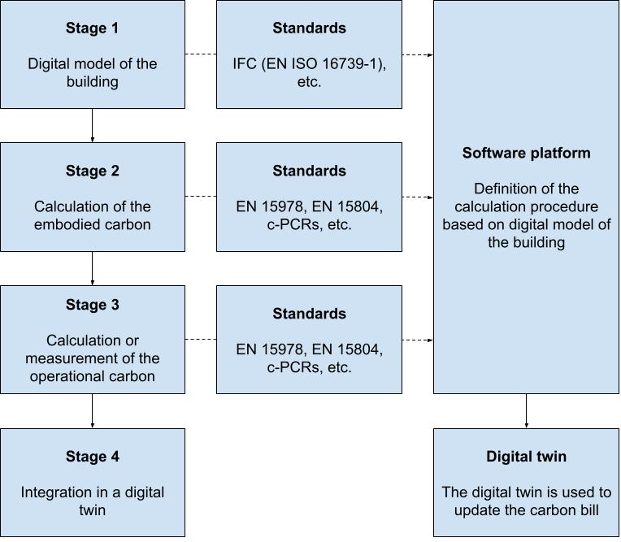
Figure 1 — Stages for the WLC-GWP calculation

Description of the stages for the WLC-GWP calculation
Stage 1 involves identification of BIM modelling requirements, preparing the data within a BIM environment, and exporting it into an information exchange file according to IFC4 schema. This process includes preparation of geometry (building elements) and building materials data based on architectural models.
Stage 2 requires the calculation of embodied carbon using LCA tools. The IFC file, defined in ISO 16739-1 [9]) is used to extract the relevant data. Material properties should then be linked to EPDs according to EN 15804, when available, to improve the accuracy of the calculations in terms of environmental impacts. EPD data should be obtained, if possible, from digital structured formats such as the data templates according to EN ISO 22057 or ILCD+EPD.
Stage 3 is based on the incorporation of real-time or near-real-time operational data obtained from sensors or other measuring devices into the assessment. This data is critical for accurately assessing operational carbon emissions. Other relevant information, such as energy bills, should be used to define the real performance of the building. The IFC file and EPD data are also used for calculations in this stage.
Stage 4 integrates the data into a digital twin from both the embodied and operational carbon calculations. This integration provides WLC emissions for the building being assessed in real-time and can be used for comprehensive analysis, simulations or decision making. The framework provided in 00442055 (CEN/TC 442/WG 9) should be used.

General criteria for the calculation of the carbon bill considering the life cycle

Introduction
The “carbon bill” is an indicator based on the calculation of the WLC (result of the aggregation of the embodied and the operational carbon of a building considering the lifecycle), which is used to set a price to GHG as an externality. It represents the financial burden imposed on society due to the environmental, health, and economic impacts resulting from climate change and pollution. The carbon bill provides a monetary measure of the harm caused by a unit or total amount of GHG emissions, used in policy-making (to quantify the economic rationale for CO₂ mitigation and adaptation policies) and to communicate the impacts on society. By establishing a price on carbon emissions, it aims to make it more expensive to emit greenhouse gases, thereby incentivizing companies and individuals to reduce their emissions

Calculation
The carbon bill can be calculated as the product of the GWP, measured as tons of CO₂ equivalent, and the price of a ton of CO₂.
The price of the for a ton of CO₂ is variable and defined as average price for predefined period of time using the for the voluntary carbon market in Europe. Subclause 6.3 describes this price of carbon credits.
To allow a better understanding of the result, it is recommended to report this carbon bill with the partial GWP results indicated in table 1: GWP_{A1-A3}, GWP_{A4}, GWP_{A5}, GWP_{B1-B5}, GWP_{B6}, GWP_{C1-C4}, GWP_{D}.

Price of carbon credits
There are several mechanisms to establish the price for a ton of CO₂:
- Spot market price, which reflects the current trading prices and is influenced by supply and demand in the short term.
- Over-the-counter transactions, which are direct agreements between buyers and sellers, based on negotiations.
- Market benchmarks provided by platforms.
In the European Union Emissions Trading System (EU ETS), the prices for EUAs are set in a carbon market, where companies buy and sell allowances based on their emissions needs. Companies with surplus allowances can sell them, while those needing more allowances must purchase them. The price is affected by several market dynamics, such as the economy activity (directly related with use of energy), energy prices or technology advances (cleaner technology reduces the need for allowances). The price of emissions allowances (European Union Allowances, EUA) traded on the European Union's Emissions Trading Scheme (ETS) reached a record high of 100.34 euros per metric ton of CO₂ in February 2023. To reduce short-term variations, this document recommends averaging the price over a period of one year. The price can be obtained for the EU ETS Auctions, which includes the information for each EU country [10]. The value used for the calculation (PE_{year}) should be the averaged result of the EU ETS Auctions during the last year for the country in which the building is located.

Additional considerations
A “discount rate” can be used to account for the present value of future damages. It can also be used to consider the differences in the knowledge of the actual impacts, as the error in the values for current operations (e.g. A1-A3) and future operations (e.g. end-of life) will differ.
Some models consider geographical variations as the impact may differ, but this document discourages this approach as it transfers the burden between regions.

Process for the definition of the refurbishment and the calculation of the carbon bill

Preassessment
It is recommended to assess the existing building and the planned refurbishment before initiating the construction work. This preassessment is based on a conceptual assessment to identify the key aspects of a building that have the most significant impact on GHG emissions (“hot spots”). These hot spots require dedicated analysis to identify mitigation strategies. A more detailed analysis involving quantified characteristics, on-site monitoring of data and LCA-tools should be made. Furthermore, comparisons between buildings with similar functions can be made at this level using established criteria to ensure consistency. If a digital model of the building is available, it should be used for this preassessment.

Recommendations for the refurbishment
If the LCA study identifies processes with an abnormally high contribution to the GWP, the report should include actions available to the building owner or manager to reduce GHG emissions. These should be reported as “mitigation strategies”, indicating where possible the estimation of the “mitigation potential”.
NOTE: Examples of mitigation strategies are the improvement of the systems (e.g., HVAC or lighting) or retrofit with better insulation.
Digital tools for the planning of renovations and refurbishments may be used. These tools include catalogs of predefined measures and allow for the generation of scenarios. The Renovation Planner developed in Chronicle [7] can also issue Building Renovation Passports (BRP) for the refurbishment.
The designer should assess these mitigation strategies and consider if a revision of the planner refurbishment is needed. The final report (see 8) should include information about the mitigation strategies applied or discarded, including a justification for those not applied.

Assessment of the as-built
The carbon bill of the refurbishment process is the comparison between the existing buildings, without any renovation or refurbishment operation, and the building once refurbished (as-built). GWP from any process before the refurbishment (for example, installations in A5) is not accounted for. Figure 2 illustrates this concept, with the following considerations:
- GWP of the processes BEFORE the refurbishment, represented green, are equal between the two situations and can be excluded.
- GWP of the processes AFTER the refurbishment, represented blue, is assessed according to EN 15978.
- GWP of the processes WITHOUT the refurbishment, represented pink, is assessed according to EN 15978.

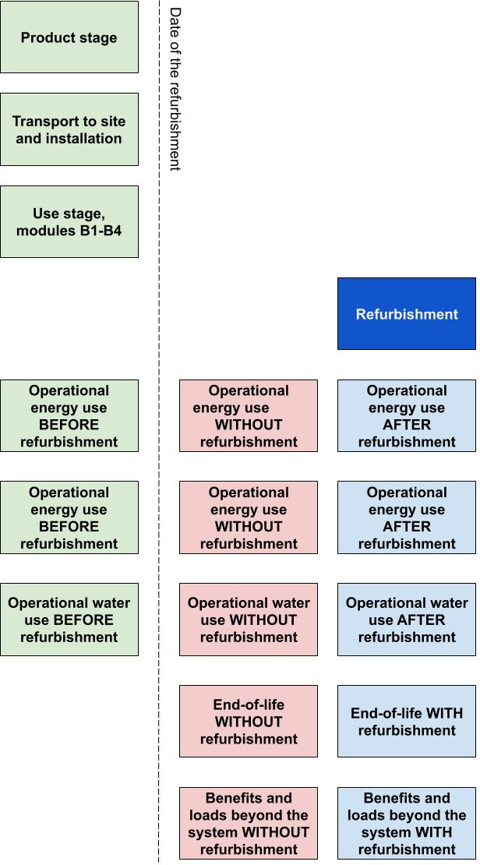

Figure 2 — Illustration of the carbon bill of the refurbishment

The GWP_{refurbishment} can be defined as:
GWP_{B5} + (GWP_{B1-B4,refur} + GWP_{B6,refur} + GWP_{B7,refur} + GWP_{C1-C4,refur} + GWP_{D,refur}) – (GWP_{B1-B4,initial} + GWP_{B6,initial} + GWP_{B7,initial} + GWP_{C1-C4,initial} + GWP_{D,initial})
Where:
GWP_{refurbishment} represents the net GWP of the refurbishment, based on the comparison of the existing conditions in the building and the refurbished building
GWP_{B5} represents the GWP of the refurbishment activities (module B5)
GWP_{B1-B4,refur} represents the GWP of modules B1-B4 after the refurbishment
GWP_{B6,refur} represents the GWP of module B6 after the refurbishment
GWP_{B7,refur} represents the GWP of module B7 after the refurbishment
GWP_{C1-C4,refur} represents the GWP of modules C1-C4 of the refurbished building
GWP_{D,refur} represents the GWP of the of module D of the refurbished building
GWP_{B1-B4,initial} represents the GWP of modules B1-B4 of the building without the refurbishment after the date of the refurbishment
GWP_{B6,initial} represents the GWP of module B6 of the building without the refurbishment after the date of the refurbishment
GWP_{B7,initial} represents the GWP of module B7 of the building without the refurbishment after the date of the refurbishment
GWP_{C1-C4,initial} represents the GWP of the building without the refurbishment
GWP_{D,initial} represents the GWP of the building without the refurbishment

As indicated in 6.2, the carbon bill is the product of the GWP (in tons of CO₂,_{eq} and the price of a ton or carbon. Therefore, CB_{refurbishment} can be calculated as follows:
CB_{refurbishment =} GWP_{refurbishment} x PE_{year}.
If a digital model is used, the carbon bill can be updated based on real-data such as meters, energy bills, etc.

Normalization, update and reporting of the carbon bill of the refurbishment
The results for the carbon bill (CB) should be reported in monetary units, e.g. euros (€). It is recommended to report the partial GWP results used for the calculation in 7 and the value of PE_{year} used.
For comparison purposes, the results may be normalized per unit area (e.g., kg CO₂e/m²) or occupant (e.g., kg CO₂e/person).
The report should also include information of the GWP partial indicators used for the calculation in 7.3; i.e. GWP_{B5}, GWP_{B1-B4,refur}, GWP_{B6,refur}, GWP_{B7,refur}, GWP_{C1-C4,refur}, GWP_{D,refur}, GWP_{B1-B4,initial}, GWP_{B6,initial}, GWP_{B7,initial}, GWP_{C1-C4,initial}, GWP_{D,initial}. If available, this information can be declared using the additional GWP impact categories defined in EN 15804+A2, i.e. GWP_{fossil}, GWP_{biogenic} and GWP_{luluc}.
The report should also include the “mitigation strategies” (see 7.1) adopted in the refurbishment and those discarded, with a justification for those not applied.
In case of updated calculations based on a digital model, the report should include any relevant deviation from the previous results based on real-data, with a discussion about the reasons for such deviations. This information and discussion can be used to improve the digital model and also to be used for future assessments.
The report should also state the limitations of the results, i.e. the monetization of GHG emissions aspects and impacts, indicating that an environmental assessment requires the inclusion of additional impact categories and indicators related to water quality, circularity, etc.

Bibliography

[1] | European Union, Directive (EU) 2024/1275 of the European Parliament and of the Council of 24 April 2024 on the energy performance of buildings (recast), 2024.
[2] | European Union, Regulation (EU) 2024/3110 of the European Parliament and of the Council of 27 November 2024 laying down harmonised rules for the marketing of construction products and repealing Regulation (EU) No 305/2011, 2024.
[3] | A. Aragón and M. G. Alberti, "Limitations of machine-interpretability of digital EPDs used for a BIM-based sustainability assessment of construction assets," J. Build. Eng., vol. 96, no. 110418, 2024.
[4] | International Organization for Standardization, ISO 22057:2022 Sustainability in buildings and civil engineering works. Data templates for the use of environmental product declarations (EPDs) for construction products in building information modelling (BIM), 2022a.
[5] | J. Anderson y A. Rønning, «Using standards to maximise the benefit of digitisation of construction product Environmental Product Declaration (EPD) to reduce Building Life Cycle Impacts,» E3S Web Conf. Volume 349, 2022. 0th International Conference on Life Cycle Management (LCM 2021), 2022.
[6] | Chronicle, D2.2. Dynamic Level(s) approach for building and LC performance assessment, 2024.
[7] | CHRONICLE, D4.3 Tool suite for WLC assessment and climate neutral building renovation planning: (1st revision), 2024.
[8] | CHRONICLE, D2.1 Business requirements, Use cases & System architecture, 2024.
[9] | International Organization for Standardization, ISO 16739-1:2024 Industry Foundation Classes (IFC) for data sharing in the construction and facility management industries. Part 1: Data schema, 2024.
[10] | European Energy Exchange AG, «EEX EUA Primary Auction Spot - Download,» [En línea]. Available: https://www.eex.com/en/market-data/environmental-markets/eua-primary-auction-spot-download. [Último acceso: 29 11 2024].
[11] | International Organization for Standardization, ISO 22057:2022 Sustainability in buildings and civil engineering works. Data templates for the use of environmental product declarations (EPDs) for construction products in building information modelling (BIM), 2022.

Source: European Environmental Agency data for 2022 (https://climate-energy.eea.europa.eu/topics/energy-1/energy-and-buildings/data last checked 2024-11-28)
Source: https://www.statista.com/statistics/1322214/carbon-prices-european-union-emission-trading-scheme/#:~:text=EU%2DETS%20allowance%20prices%20in%20the%20European%20Union%202022%2D2025&text=The%20price%20of%20emissions%20allowances,of%20CO%E2%82%82%20in%20February%202023.

